1. Website:
   1. Generate QR Codes that can be printed.
2. Mobile Wallet
   1. Registration
      1. Generate MMID for a Mobile number.
      2. Ability to change mobile number or unregister a mobile number.
      3. Ability to accept E-KYC documents.
   2. Operations
      1. Can hold Money Balance
      2. Can transfer to other accounts via IMPS
      3. Can transfer to other accounts in same wallet
      4. Can receive payments (Credits) by below means
         1. IMPS transfer in from any account.
         2. Transfer from other accounts in the same wallet. We can upload money into the account by making cash payments at merchant locations.
      5. Has a ledger of all transactions on the mobile wallet.
      6. Ability to generate SMS for all payments received or made.
         1. User can opt for notifications within the ledger instead of an SMS.
3. Mobile wallet ledger.
   1. This ledger is already ingrained in the mobile of the wallet with the SIM of registered mobile number. In order to facilitate the tracking of payments by multiple payment counters for the same wallet account, the mobile ledger can be installed on any other mobile instrument (with or without SIM) to be able to view payments received and there can be a filter process on the Transaction Details field. This will help to enable payment acceptance at multiple points. For example. A super market will have 10 checkout counters and all of them can be linked to one account. The checkout counters will have a ledger filtered by the identifying reference number.

This mobile instrument can only hold the ledger for one wallet account. The installable is only configured to the account and credentials are needed when installing. A separate set of credentials are required to access the ledger.

* 1. The server side of wallet ledger can be programmed to take action receipt of payments. A payment received with a particular reference number for a certain amount would initiate some action based on these values.

Example:

1. A customer buys an item from an online e-commerce store. At the time of checkout, a QR code is displayed on the screen with a unique reference number. The customer scans the QR code and makes a payment. When the payment is received, the ledger will take action based on the reference number. The reference number will help to uniquely identify the sale and initiate the shipping process.
2. A mobile user at a railway station scans a QR code which represents a payment for an unreserved ticket for a certain amount to a particular destination. Upon receiving the payment and verifying the correct amount, an unreserved ticket SMS will be sent to the phone that made the payment.

The server side of the mobile wallet ledger can be installed on the service provider’s site.

Print QR

Generate QR

*Dropdown*

Mobile ID

MMID

OR

Account

Bank

# Wallet Functionality

## Scan and Pay

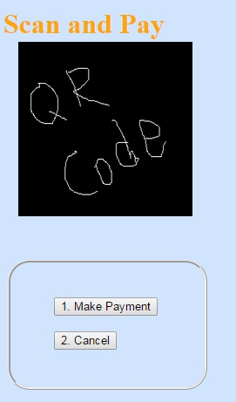

When this option is chosen, the back camera of the phone gets activated.

User focusses on QR code.

When the “Make Payment” option is chosen:

if the QR code is not readable an error message will be displayed that QR code is not readable.

If the QR code is readable, but the format of the XML does not confirm to the XML format specification, an error message is displayed that QR code is not in right format.

If the QR Code confirms to the XML format specification:

If the MMID and MOBNUM tags are available and in right format, control goes to “PAYMMIDMOBID” screen. If the MMID and MOBNUM combination exists in the contact list, the Recipient name will be picked up from there. If not, then a check is made is the combination is a easypay customer. If so, the recipient name is picked up from there.

If IFSC and ACNUM tags are available and in right format, control goes to “PAYBANKACCOUNT” screen.

If there is an issue with the format, an error message is displayed that QR code is not in right format.

Cancel Button return control to main screen.

## Pay Using MMID and Mobile Number (PAYMMIDMOBID)

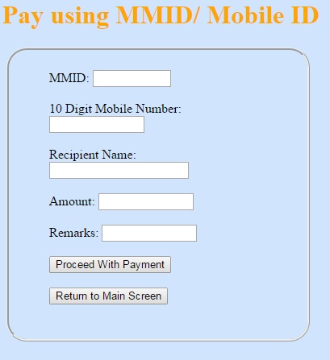

Control to this screen comes either from Scan and Pay or option on main menu.

MMID: 7 Digit Numeric. User can enter or modify an existing value.

10 Digit Mobile Number: 10 digit numeric. User can enter or modify an existing value.

Recipient Name: This is a ready only field, populated from a previous screen, otherwise blank.

Amount: Total digits 18, fractional 5. It can be modified.

Remarks (Not Mandatory): 30 Characters

When the “Proceed with Payment” button is touched the below validation happens.

1. MMID is 7 digit numeric
2. 10 Digit Mobile Number is numeric with no leading zeroes
3. A check is made if it is an Easy Pay customer. If it is, then the account must be valid and in-force at that point of time. The balance in the recipient account should not exceed the maximum allowed balance at that point of time.
4. The amount is in right format. The amount should confirm to the transaction limits for the wallet.
5. The transaction fee is calculated and a check is made to see that there is sufficient balance in the wallet. If not, an “Insufficient Balance” error is displayed.

Once all the validations are successful, control goes to Confirm Payment MMID/MOBID (PAYMMIDMOBIDCONFIRM) screen.

When the return to main screen button is touched, control goes to the main screen.

## Confirmation for Payment Using MMID and Mobile Number (PAYMMIDMOBID)

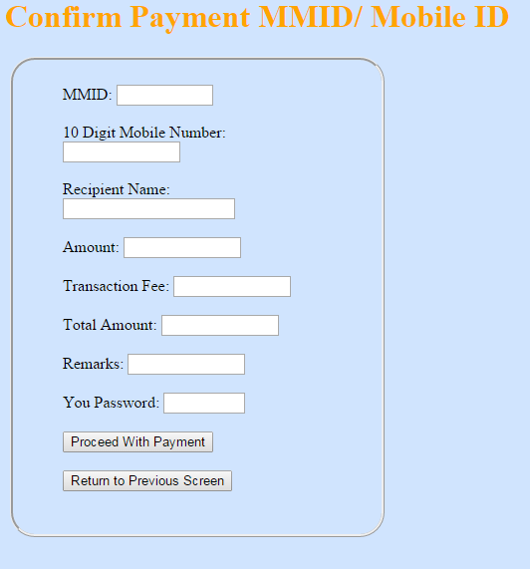

Control to this screen comes from PAYMMIDMOBID screen.

All the fields on this screen are read-only except for password.

When the Proceed with Payment button is touched:

1. The password is validated.
2. All the checks done in PAYMMIDMOBID are performed.
3. If the amount is unnatural (E.g Very high amount greater than INR 10,000 a pop-up user is asked to reconfirm.
4. The payment is processed and a message is displayed on whether the payment is successful of an error message is shown with the reason for failure.
5. If the payment seems as duplicate (recipient details and amounts are the same), the user is warned of a duplicate transaction and is asked to confirm.

If all the validations are successful, the payment is processed and control goes to the main screen.

## Pay a Bank Account (PAYBANKACCOUNT)

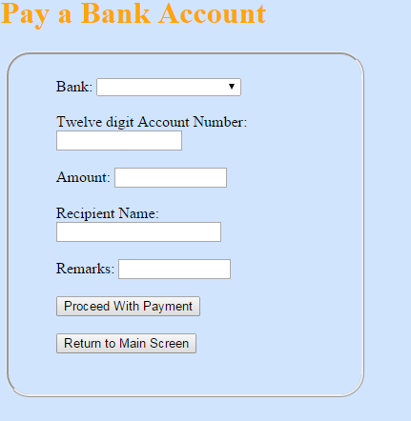

Control to this screen comes either from Scan and Pay or option on main menu.

Bank: This is a drop-down User can select from a list.

12 Digit Account Number: 12 digit numeric. User can enter or modify an existing value.

Recipient Name: This is a ready only field, populated from a previous screen, otherwise blank.

Amount: Total digits 18, fractional 5. It can be modified.

Remarks (Not Mandatory): 30 Characters

When the “Proceed with Payment” button is touched the below validation happens.

1. Bank cannot be blank.
2. 12 Digit Account Number is numeric with no leading zeroes
3. The amount is in right format. The amount should confirm to the transaction limits for the wallet.
4. The transaction fee is calculated and a check is made to see that there is sufficient balance in the wallet. If not, an “Insufficient Balance” error is displayed.

Once all the validations are successful, control goes to Confirm pay a Bank Account (PAYBANKACCOUNTCONFIRM) screen.

When the return to main screen button is touched, control goes to the main screen.

## Confirm Pay and Bank Account (PAYBANKACCOUNTCONFIRM) Screen

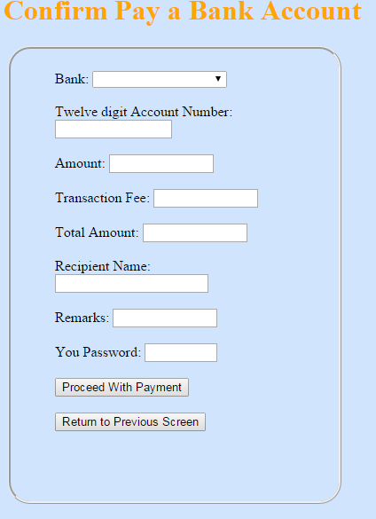

Control to this screen comes from PAYBANKACCOUNT screen.

All the fields on this screen are read-only except for password.

When the Proceed with Payment button is touched:

1. The password is validated.
2. All the checks done in PAYBANKACCOUNT are performed.
3. If the amount is unnatural (E.g. Very high amount greater than INR 10,000 a pop-up user is asked to reconfirm.
4. The payment is processed and a message is displayed on whether the payment is successful of an error message is shown with the reason for failure.
5. If the payment seems as duplicate (recipient details and amounts are the same), the user is warned of a duplicate transaction and is asked to confirm.

If all the validations are successful, the payment is processed and control goes to the main screen.

## Input XML Specification for QRCode

<?xml version=”1.0” encoding=”UTF-8”?>

<PaymentData mobid=”NNNNNNNNNN” mmid=”NNNNNNN” amount=”NNNNNNNNNNNNN.NNNNN” refid=”” ></PaymentData>

Or

<?xml version=”1.0” encoding=”UTF-8”?>

<PaymentData ifsc=”XXXXXXXXXXX” acnum=”NNNNNNNNNNNN” amount=”NNNNNNNNNNNNN.NNNNN” refid=”” ></PaymentData>